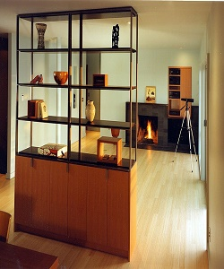

Wooden Divider

$107.79

Availability: In stock

**Description:**

Simple Wooden 25 Nifty Space Saving Room Dividers For The Living Room. this room divider can be used to define space in an open concept room, or can be set in front of a large window for privacy. Rounding out the design, metal hinges make folding and storage a breeze when not in use.